Z HOME SENSOR PCB

- PARTS:

QUANTITY: PART #: NOMENCLATURE: LENGTH:

1 PER MACHINE 09540- PCB, BLANK, X-Y LIMIT SENSOR N/A

1 PER MACHINE 18457- SENSOR, PHOTOLOGIC N/A

1 PER MACHINE 15332- RESISTOR, 220Ω, ¼W, 5% N/A

1 PER MACHINE 17585-2 HOUSING, 3-PIN, MOLEX N/A

3 PER MACHINE 18729- TERMINAL, CRIMP, GOLDPLATED N/A

1 PER MACHINE 19102- WIRE, RED, 22 AWG 9 INCHES

1 PER MACHINE 19106- WIRE, BROWN, 22 AWG 9 INCHES

1 PER MACHINE 19105- WIRE, BLUE, 22 AWG 9 INCHES

1 PER MACHINE 46776- SLEEVE, ¼” BLACK 7 INCHES

- ASSEMBLY:

- INSERT AND SOLDER THE RESISTOR, ACCORDING TO DIAGRAM 1.

- INSERT THE SENSOR WITH THE WRITTEN-SIDE FACING THE RESISTOR, ACCORDING TO DIAGRAM 1.

- SLIDE THE SLEEVING ON THE WIRES.

- STRIP 1/8 INCH FROM THE ENDS OF THE WIRES.

- INSERT AND SOLDER THE WIRES TO THE PCB, ACCORDING TO DIAGRAM 1.

- CRIMP AND TIN THE GOLD-PLATED TERMINALS TO THE WIRES, ACCORDING TO
DIAGRAM 2.

- INSERT THE CRIMPED WIRES INTO THE HOUSING, ACCORDING TO DIAGRAM 3.

NOTE 1
IT IS CRITICAL TO INSERT THE WIRES INTO THE PCB AND HOUSING ACCORDING TO DIAGRAMS 1 AND 3. ANY VARIATION MAY CAUSE MALFUNCTION OR DAMAGE TO CIRCUITRY.

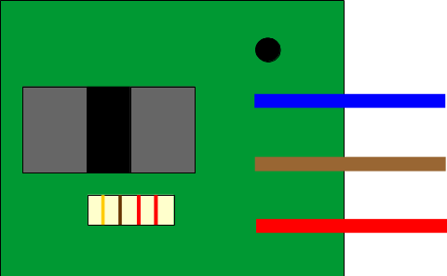

DIAGRAM 1



DIAGRAM 2



DIAGRAM 3

